Document Model

📄 What is the Document Data Model?
# Source: AI Source: Provided by: [Data Path: Persons Table -> ID Column: 1, Name_En Column: Motasem Essam] -> From: [ChatGPT] on [6/10/2026]
The Document Model is a type of NoSQL data model where data is stored as documents, usually in formats like JSON, BSON, or XML.
📌 Each document is a self-contained unit of data — much like a record — that can store structured, semi-structured, or nested data.

🧠 Key Concept
# Source: AI Source: Provided by: [Data Path: Persons Table -> ID Column: 1, Name_En Column: Motasem Essam] -> From: [ChatGPT] on [6/10/2026]
- Data is stored in documents, not rows and tables.
- Each document contains key–value pairs, arrays, and even nested objects.
- Documents are stored in collections, not tables.

📦 Example: JSON Document (Student Record)
# Source: AI Source: Provided by: [Data Path: Persons Table -> ID Column: 1, Name_En Column: Motasem Essam] -> From: [ChatGPT] on [6/10/2026]
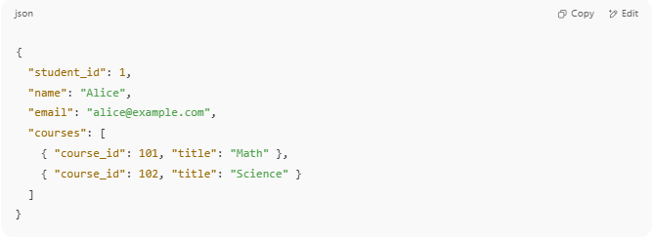
{
"student_id": 1,
"name": "Alice",
"email": "alice@example.com",
"courses": [
{ "course_id": 101, "title": "Math" },
{ "course_id": 102, "title": "Science" }
]
}

✔️ This single document contains:
- Basic attributes (ID, name)
- A nested array of courses

🧾 Structure Overview
# Source: AI Source: Provided by: [Data Path: Persons Table -> ID Column: 1, Name_En Column: Motasem Essam] -> From: [ChatGPT] on [6/10/2026]
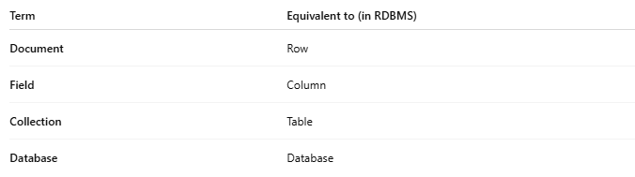
Term | Equivalent to (in RDBMS)
Document | Row
Field | Column
Collection | Table
Database | Database

✅ Advantages of Document Model
# Source: AI Source: Provided by: [Data Path: Persons Table -> ID Column: 1, Name_En Column: Motasem Essam] -> From: [ChatGPT] on [6/10/2026]
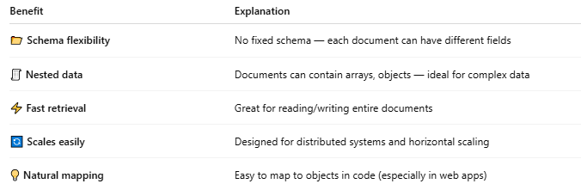
Benefit | Explanation
📂 Schema flexibility | No fixed schema — each document can have different fields
🧾 Nested data | Documents can contain arrays, objects — ideal for complex data
⚡ Fast retrieval | Great for reading/writing entire documents
🔄 Scales easily | Designed for distributed systems and horizontal scaling
💡 Natural mapping | Easy to map to objects in code (especially in web apps)

❌ Disadvantages
# Source: AI Source: Provided by: [Data Path: Persons Table -> ID Column: 1, Name_En Column: Motasem Essam] -> From: [ChatGPT] on [6/10/2026]
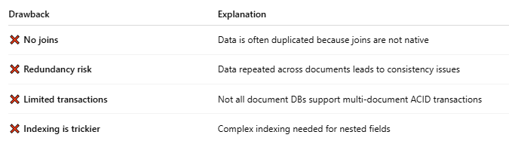
Drawback | Explanation
❌ No joins | Data is often duplicated because joins are not native
❌ Redundancy risk | Data repeated across documents leads to consistency issues
❌ Limited transactions | Not all document DBs support multi-document ACID transactions
❌ Indexing is trickier | Complex indexing needed for nested fields

🔧 Popular Document-Based Databases
# Source: AI Source: Provided by: [Data Path: Persons Table -> ID Column: 1, Name_En Column: Motasem Essam] -> From: [ChatGPT] on [6/10/2026]
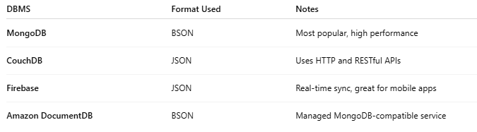
DBMS | Format Used | Notes
MongoDB | BSON | Most popular, high performance
CouchDB | JSON | Uses HTTP and RESTful APIs
Firebase | JSON | Real-time sync, great for mobile apps
Amazon DocumentDB | BSON | Managed MongoDB-compatible service

🧠 Use Cases
# Source: AI Source: Provided by: [Data Path: Persons Table -> ID Column: 1, Name_En Column: Motasem Essam] -> From: [ChatGPT] on [6/10/2026]
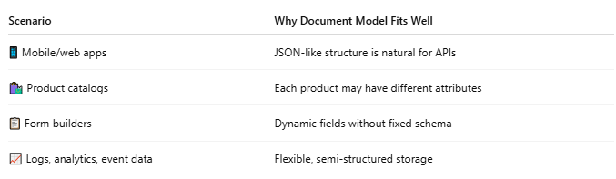
Scenario | Why Document Model Fits Well
📱 Mobile/web apps | JSON-like structure is natural for APIs
🛍️ Product catalogs | Each product may have different attributes
📋 Form builders | Dynamic fields without fixed schema
📈 Logs, analytics, event data | Flexible, semi-structured storage

🆚 Relational vs Document Model
# Source: AI Source: Provided by: [Data Path: Persons Table -> ID Column: 1, Name_En Column: Motasem Essam] -> From: [ChatGPT] on [6/10/2026]
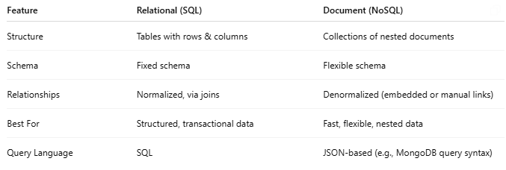
Feature | Relational (SQL) | Document (NoSQL)
Structure | Tables with rows & columns | Collections of nested documents
Schema | Fixed schema | Flexible schema
Relationships | Normalized, via joins | Denormalized (embedded or manual links)
Best For | Structured, transactional data | Fast, flexible, nested data
Query Language | SQL | JSON-based (e.g., MongoDB query syntax)

🧠 Summary
# Source: AI Source: Provided by: [Data Path: Persons Table -> ID Column: 1, Name_En Column: Motasem Essam] -> From: [ChatGPT] on [6/10/2026]
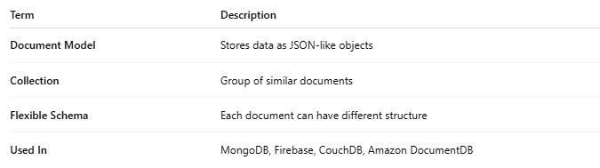
Term | Description
Document Model | Stores data as JSON-like objects
Collection | Group of similar documents
Flexible Schema | Each document can have different structure
Used In | MongoDB, Firebase, CouchDB, Amazon DocumentDB

